KARUPPASAMY S

FLIPKART’S MOBILE SALES ANALYSIS



# INTRODUCTION

Flipkart is an Indian e-commerce company, headquartered in Bangalore, Karnataka, India. It is the largest e-commerce company in India and was founded by Sachin and Binny Bansal. The company has wide variety of products electronics like laptops, tablets, smartphones, and mobile accessories to in- vogue fashion staples like shoes, clothing and lifestyle accessories; from modern furniture like sofa sets, dining tables, and wardrobes to appliances that make your life easy like washing machines, TVs, ACs, mixer grinder juicers and other time-saving kitchen and small appliances; from home furnishings like cushion covers, mattresses and bedsheets to toys and musical instruments.

## Mobile Phones

Mobile phones are one of the most rapidly rising industries, as well as one of the most prominent industries in the technology sector. The rate of increase has been exponential, with the number of mobile phone customers increasing fivefold in the last decade. Globally, the number of smartphones sold to end users climbed from 300 million in 2010 to 1.5 billion by 2020.

## Flipkart and Mobile Phones

As previously stated, mobile phones are in high demand and are one of the ideal products for a novice to sell. Flipkart will be the ideal spot for a vendor to market their stuff because its reach.

**BUSINESS PROBLEM**

The objective is to address a hypothetical business problem for a Flipkart Authorized Seller. According to the problem the individual is looking to sell mobile phones on Flipkart. For this, the individual is looking for the best product, brand, specification and deals that can generate the most revenue with the least amount of investment and budget constraints.

Questions to be answered:

1. Should he simply sell products for one brand, or should he try to sell models from various brands?
2. Using EDA and Data Visualization find out insights and relation between different features.
3. Perform detailed analysis of each brand.

# ABOUT DATASET

The dataset includes data on mobile phones from the top five most popular brands in India: Apple, Poco, Realme, Samsung, and Xiaomi. Information like RAM, ROM, Display Size. etc are present which distinguishes one product from another. At least one attribute distinguishes each product. Dataset has no null value.

Columns: There are 16 columns each having a title which is self-explanatory. Rows: There are 430 rows each having a mobile with at least a distinct feature.

DESCRIPTION OF ATTRIBUTES

* 1. **brand**: Brand Name (Categorical)
  2. **model**: Model Name (Categorical)
  3. **base_color**: Phone Color (Categorical)
  4. **processor**: Processor brand used (Categorical)
  5. **screen_size**: Categorical screen size (Categorical)
  6. **ROM**: ROM in gigabyte (Numeric – Discrete)
  7. **RAM**: RAM in gigabyte (Numeric – Discrete)
  8. **display_size**: Actual display size in inches (Numeric – Continuous)
  9. **num_rear_camera**: No. of cameras on back (Numeric – Discrete)
  10. **num_front_camera**: No. of cameras on front (Numeric – Discrete)
  11. **battery_size**: Battery in mAH (Numeric – Continuous)
  12. **ratings**: Customer rating for the product (Numeric – Continuous)
  13. **num_of_ratings**: No. of people rating the product, also the equivalent no. of unit sold for our problem (Numeric – Continuous)
  14. **sales_price**: Selling price of the unit after discount (Numeric –

Continuous)

* 1. **discount_percent**: Discount in percentage offered (Numeric –

Continuous)

* 1. **sales**: Sales of product in crore rupees (Numeric – Continuous)

# EXPLORATORY DATA ANALYSIS

EDA is one of the most important phases in data science since it helps us to obtain critical insights and statistical metrics. In general, EDA can be categorised in two ways.

The first distinction is that each method is either non-graphical or graphical. Second, each method is univariate or multivariate in nature (usually just bivariate).

Non-graphical approaches typically include the computation of summary statistics, but graphical methods clearly summarize the data in a diagrammatic or pictorial manner.

Let's look at each type individually.

## INSTANCE OF THE DATASET

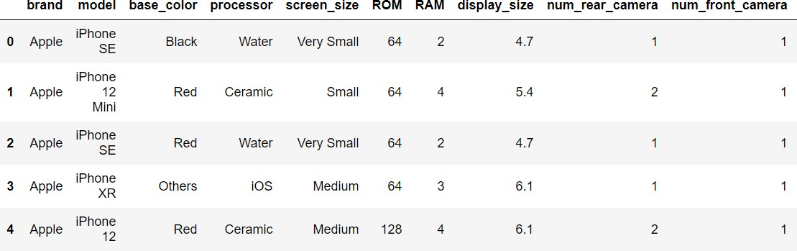

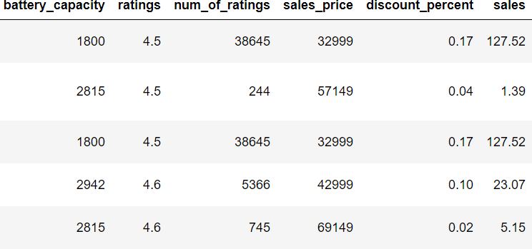

**DESCRIPTIVE STATISTICS (NON-GRAPHICAL)**

In this section, we will look at the Measures of Central Tendency (Mean, Median, Mode) and Measures of Dispersion (Standard Deviation, Range and Quartiles).

Numerical Features

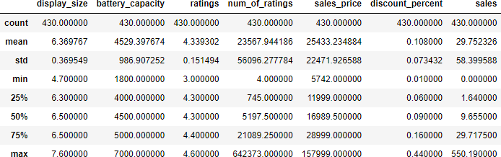

**Correlation matrix**

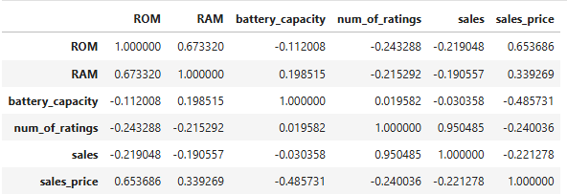

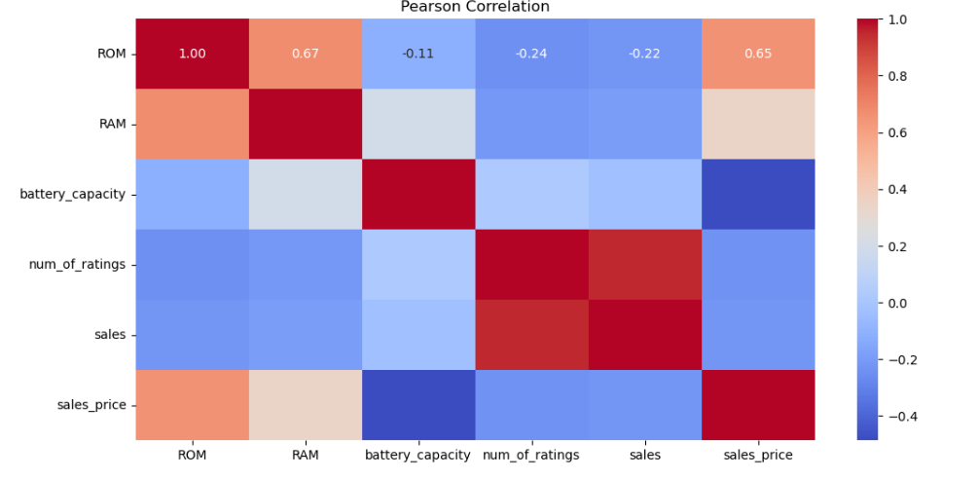

**INSIGHTS**

* Strong positive correlation between ROM and RAM, indicating that devices with higher ROM tend to also have higher RAM.
* Strong positive correlation between ROM and sales_price.
* Strong positive correlation between Number of ratings and Sales, indicating that devices with more number of ratings(users) tend to have higher Sales.

**Density plot for sale price**

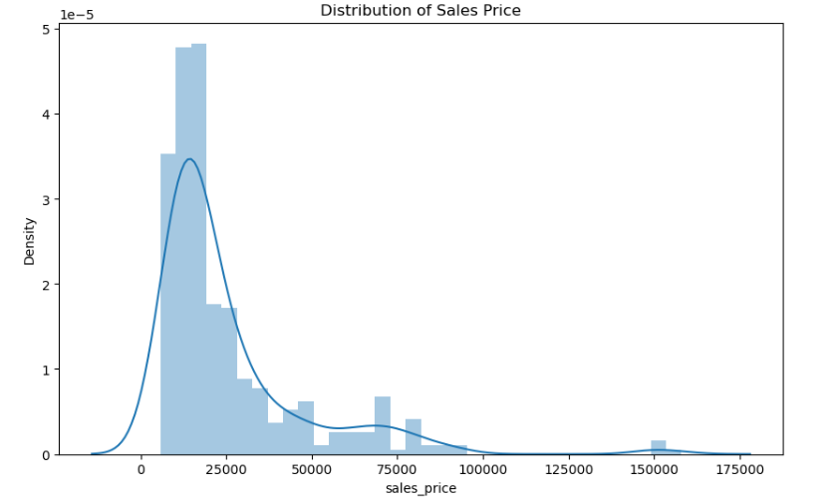

**Count plot for mobile brand**

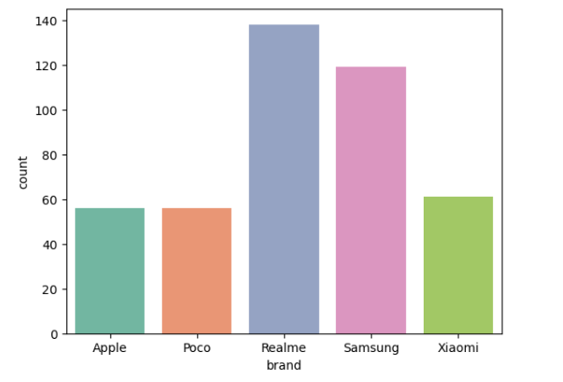

**Mobile processor**

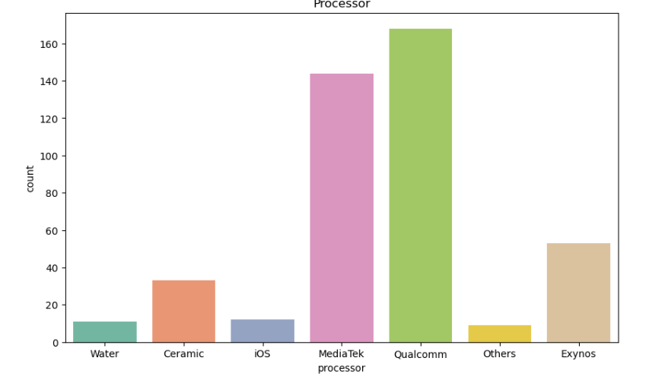

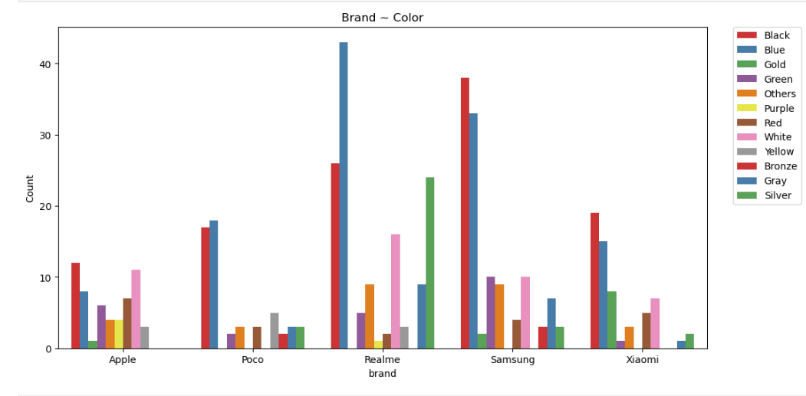

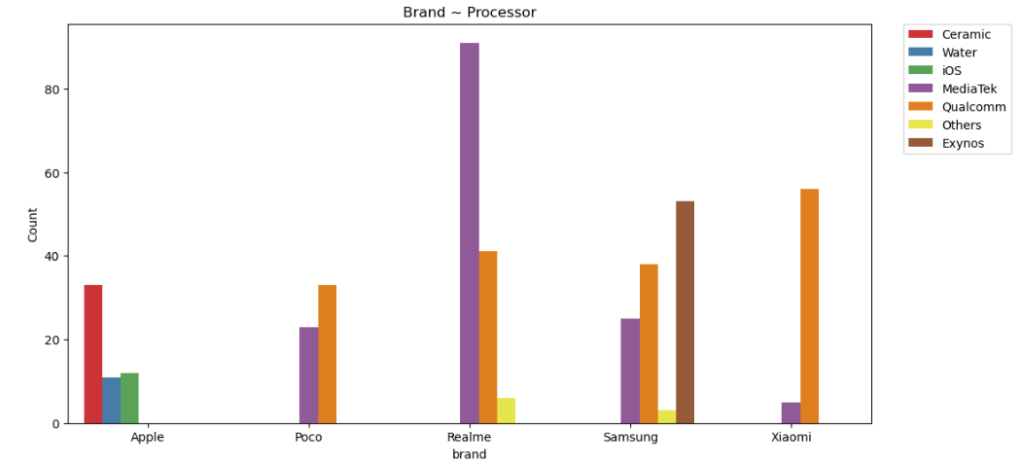

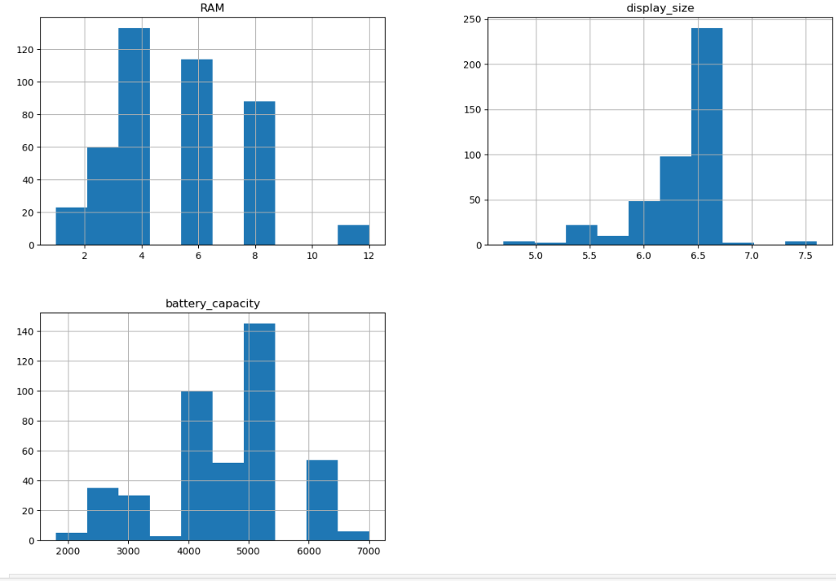

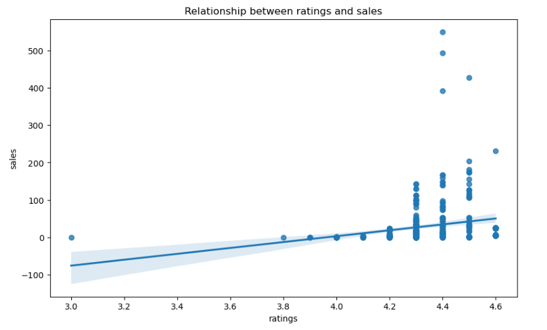

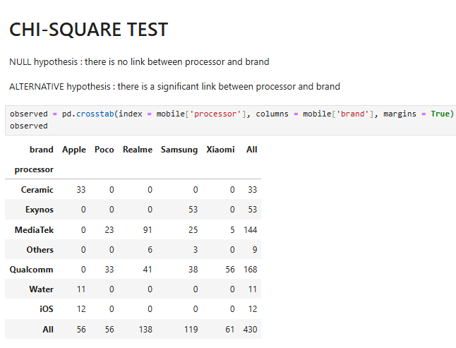

**Insights :**

p_value < alpha value : Reject NULL HYPOTHESIS, so we have enough evidence to support ALTERNATE Hypothesis__there is no link between base_color and brand

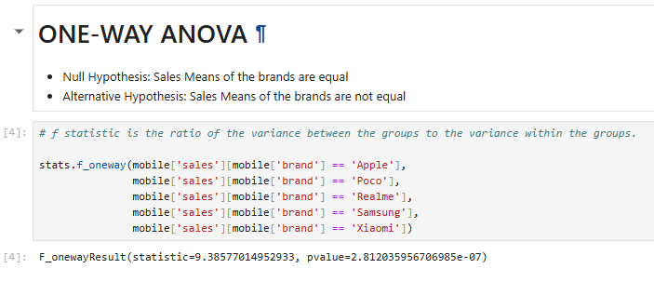

### Insights:

* pvalue < alpha value : Reject NULL HYPOTHESIS, so we have enough evidence to support ALTERNATE HYPOTHESIS which is Sales Means of the brands are not equal.